Introduction: Data Migration in SCIKIQ
SCIKIQ’s Data Migration module provides a user-friendly, wizard-based interface for migrating data across heterogeneous environments. Whether you're moving structured data from an on-premise Oracle database to a modern cloud-native platform like Vertica, or syncing operational datasets across systems, this module simplifies complex migrations with guided steps, real-time validation, and metadata intelligence.
It enables data architects, analysts, and admins to migrate schemas, perform delta synchronization, validate data integrity, and streamline replication — all without writing code. This document outlines the step-by-step procedure to perform a typical migration from Oracle to Vertica using SCIKIQ’s Migration Hub.
Accessing the Data Migration Module
In the SCIKIQ Connect navigation panel, go to the Scikiq Migration Hub section and select Data Migration. This section houses tools to create and manage migration pipelines.
Here, users can:
  - Initiate a new migration workflow
  - View previous migration requests
  - Monitor schema transfers and transformation jobs
  - Access migration logs

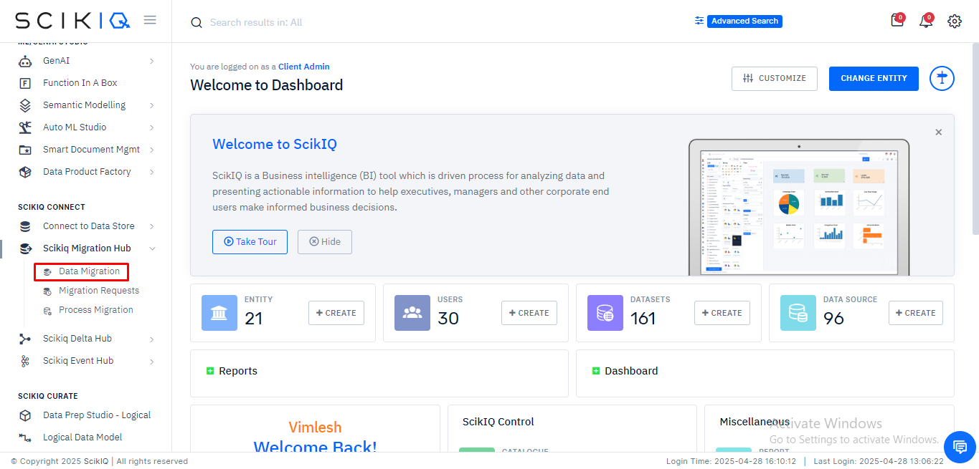
Launching the Data Migration Wizard
Upon selecting Data Migration, users are directed to the Data Migration Wizard, which provides a six-step guided process:
- Get Started – A brief introduction to the migration journey.
- Source & Target – Configure your source and target databases (e.g., Oracle to Vertica).
- Migration – Select tables to be migrated.
- Analyze & Sync – Profile, validate, and optionally enable sync jobs.
- POD Management – Manage jobs and pipelines.
- Review & Submit – Final review and execution of migration.
This interface visually communicates the flow: Source → Target → Schedule & Run, emphasizing ease of use even for non-technical users.
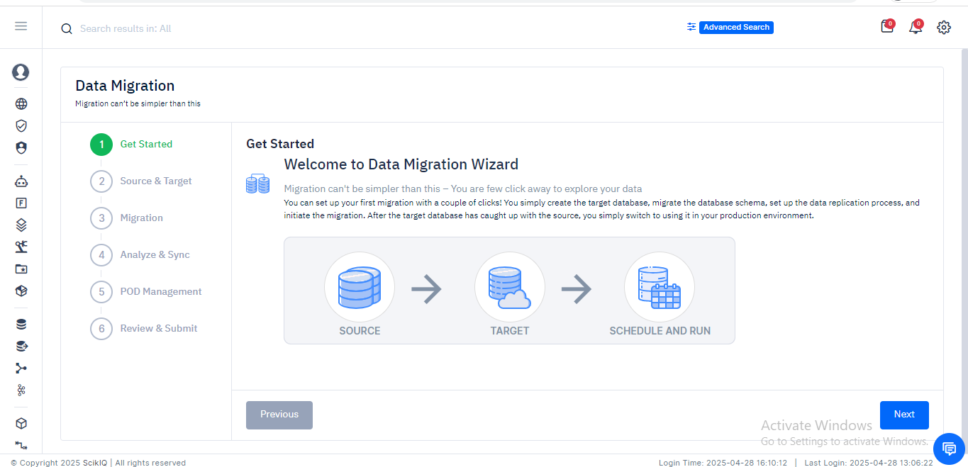
Source & Target Configuration (Continued)
Once users are welcomed into the migration wizard and understand its high-level functionality (source → target → schedule), the next crucial stage involves defining where the data comes from and where it needs to go. This is handled in the "Source & Target" section.
Selecting the Data Source Type
This screen allows the user to specify the source database system from which data will be migrated.
Process Steps
- Navigate to the Source & Target tab.
- Under Source Information, click the dropdown next to “Select Data Source Type.”
- A list of supported source systems appears, including:
  - Oracle
  - MySQL
  - Postgres
  - Redshift
  - SAP HANA
- Select Oracle as the source type for this scenario.
- Once selected, the system prompts for a connection. Users must choose an existing Oracle connection or set one up via the connection manager.
Note: Supported source databases reflect SCIKIQ’s interoperability with major enterprise platforms.

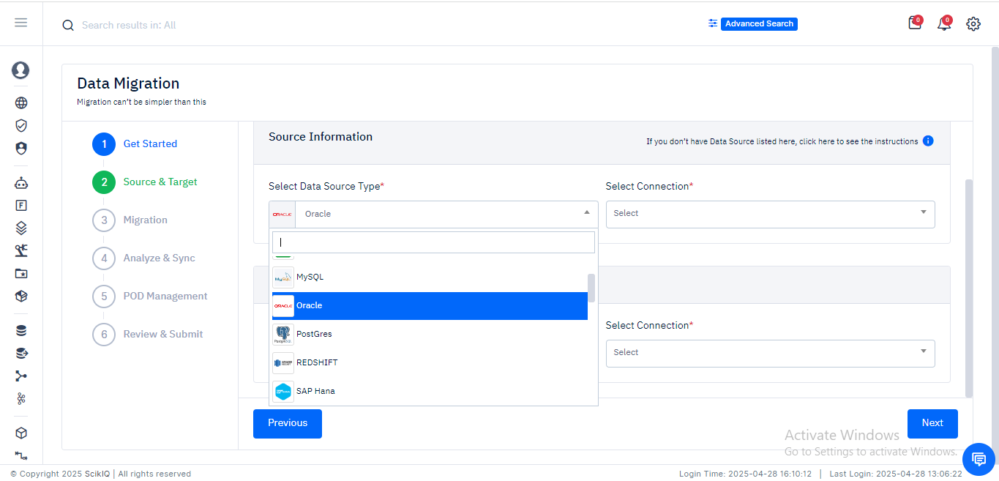

Providing Source and Target Connection Details
This screen finalizes the source and target systems for the migration job.
Process Steps:
- Source Information:
  - The user selects Oracle as the source.
  - Connection details such as host IP, schema name, and connection alias appear.
  - This verifies that the data to be extracted is from a known Oracle instance.
- Target Information:
  - The user now defines the destination by selecting the target type — in this case, SCIKIQ DNA Hub.
  - A predefined connection like VS_SciKiQ is chosen.
  - The system also displays the target host IP and schema name in read-only fields for validation.
- Once source and target details are populated and verified, the user clicks Next to proceed to the Migration step.
Ensure both source and target schemas are accessible and validated by performing a quick test connection prior to proceeding.

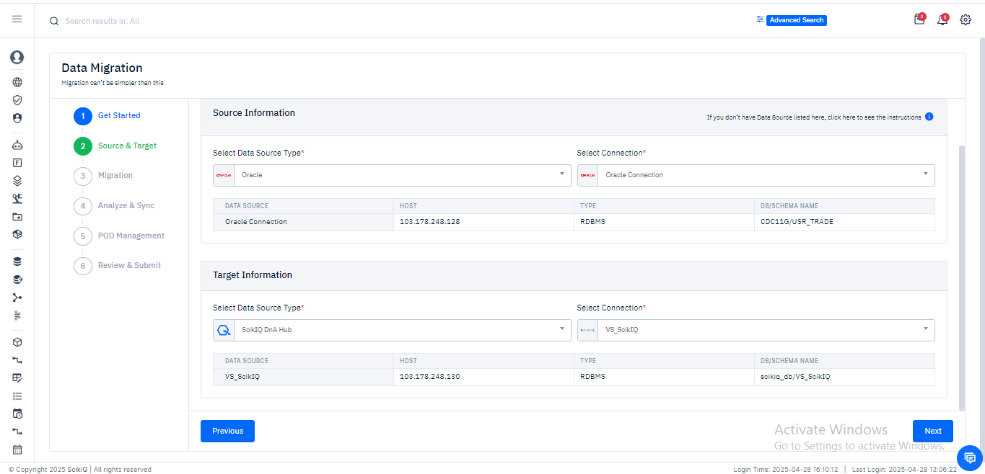

Migration – Table Selection
Once the source and target connections are configured, the next step in the Data Migration Wizard is selecting the tables you want to migrate from the source database (Oracle) to the target (Vertica).
Source Table List View
This screen presents the complete list of available tables in the Oracle source database.
- On the left panel, the available source tables are listed along with their row count and column count, giving a quick view of the data volume.
- You can use the search box to quickly locate tables by name.
- The right-pointing arrow buttons allow you to move one or more selected tables from the source list to the target list for migration.
- Use the double arrow buttons to move all tables at once.
- A checkbox at the bottom labeled Bi-Directional Relationship indicates whether synchronization should occur in both directions (source ↔ target) post-migration. This is optional and can be disabled for one-way syncs.
Only move the necessary tables for the migration scope to keep the process optimiz

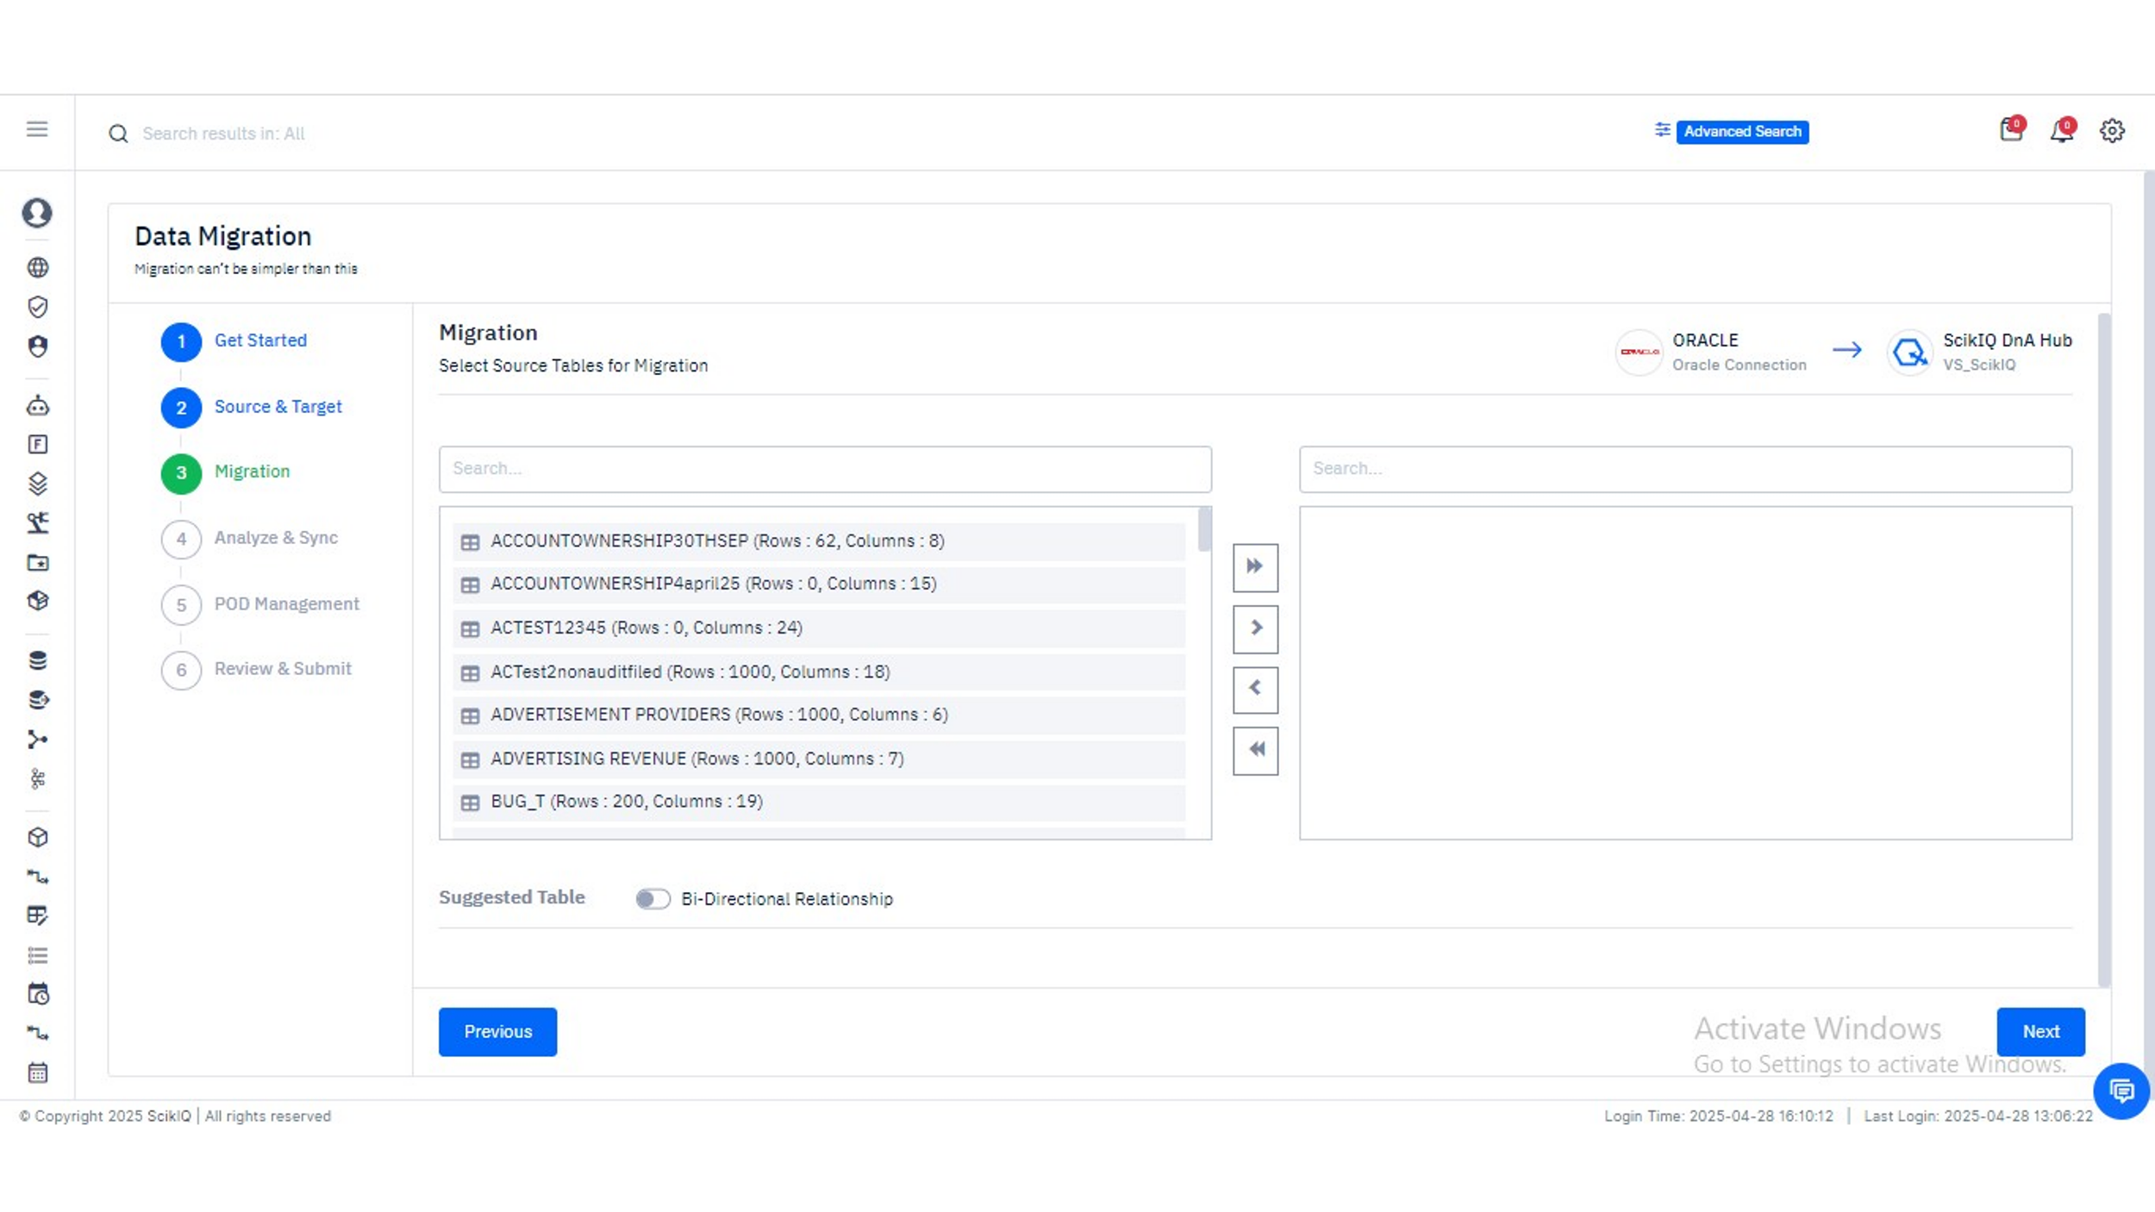
Finalized Table Selection
After filtering and choosing your relevant source tables, the selected items appear in the right-hand panel.
- In this image, two tables — TRADES and TRADE_OPTIONS — have been moved to the right pane, indicating that they are finalized for migration.
- This selection now defines the scope of your actual data migration process.
- You may continue adding more tables or remove ones by using the reverse arrow buttons.
Review row and column counts to validate whether a table’s size aligns with sync strategy or storage constraints at the destination.

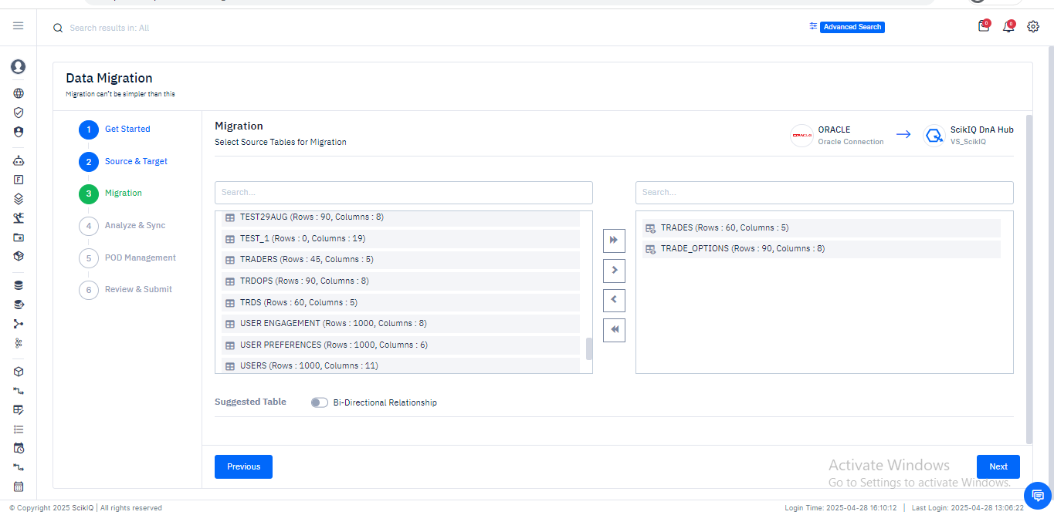

Analyze & Sync
Once the source and target configurations are established and tables for migration are selected, the next critical phase is Analyze & Sync. This step ensures that the migrated data remains continuously synchronized between the source and the destination, offering support for scheduled sync jobs and fine-grained data control.

Analyze & Sync: Select Table and Configure Sync Settings
- Enable Sync Job:
At the top, the "Enable Sync Job" toggle is activated to allow continuous synchronization between Oracle and Vertica after migration.
- Select Table for Syncing:
From the dropdown under "Select Table", users can choose which tables (e.g., TRADES, TRADE_OPTIONS) they want to monitor and sync post-migration.
- Edit Columns / Metadata:
There is an option to edit columns and metadata settings before synchronization. You can enable:
  - Infer Schema: To automatically detect and adapt schema changes.
  - Enable Audit Fields: To track data modifications during sync.
- Score Card:
Displays a quick snapshot of the total number of columns and records being managed.
- Settings:
Users can configure:
  - Batch Size (e.g., 10,000 records) for sync operations to control data load and performance.
  - Mark as Dimension: Useful for analytical models where dimension tables must be separated.
  - Create Daily Delta Job: Automatically set up delta jobs to sync only the changes daily, ensuring efficiency without reloading complete datasets.
This image represents setting up the foundational configuration for a sync pipeline — enabling users to maintain data freshness between Oracle and Vertica automatically.
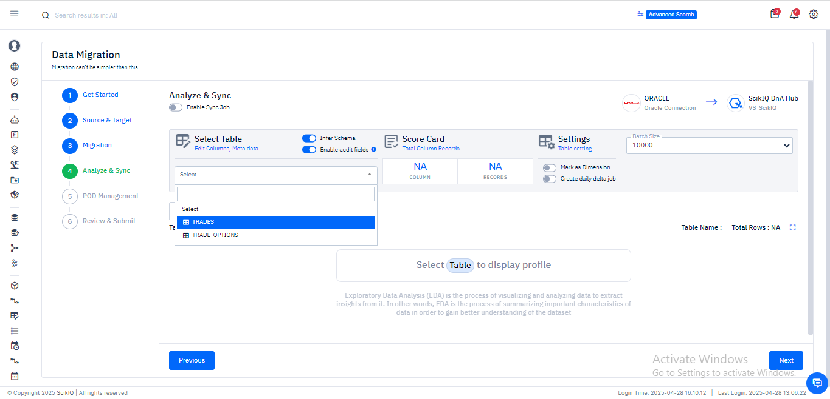

Analyze & Sync: Manage Sync Jobs with Kafka Integration
- Drag and Drop Sync Management:
Users can drag and organize tables for different job types:
  - Truncate Jobs: Deletes and reloads tables completely on sync.
  - Batch Processing Jobs: Loads new data batches without full table truncation (configured under "Schedule 1").
  - Incremental CDC (Change Data Capture): Tracks and syncs only changed rows (optional).
  - Log-Based CDC: Advanced mechanism for near-real-time replication based on transaction logs (optional).
- Kafka Integration:
Kafka Server selection is available, indicating that you can stream real-time change data events to Kafka topics if needed for advanced integration and real-time analytics scenarios.
This image focuses on organizing how synchronization should happen operationally — either through complete reloads, incremental syncs, or log-based methods — while offering the ability to stream changes via Kafka for real-time use cases.

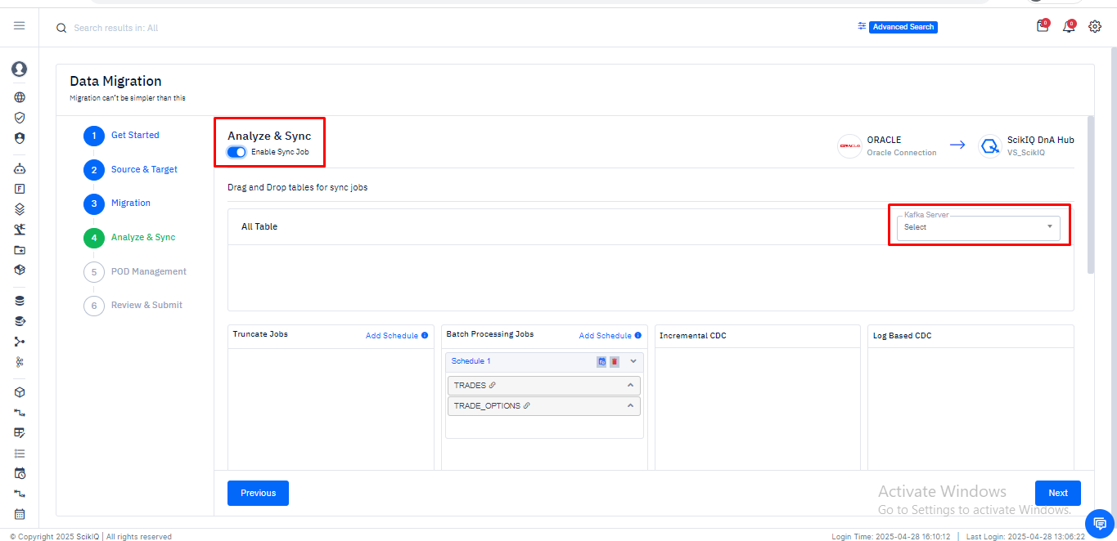

Column Profiling & Advanced Settings (Analyze & Sync)
Once tables are added to the sync pipeline, this stage provides tools to inspect and prepare the data schema before finalizing the migration and sync process.

Column-Level Profiling, Data Tags & Validation Tools
This screen offers in-depth column profiling, enabling users to assess data distribution, quality, and metadata attributes before migration.
Key Sections Highlighted:
- Table Profile: Displays column-wise stats such as data type (INT, FLOAT, DATE), record distributions, and sample values for easy analysis.
- Tagging Options (highlighted in yellow/blue/red box):
  - Unique Key: Marks the column as a unique identifier.
  - Filter: Applies filter conditions to the data.
  - Meta Data: Displays metadata information like data types and nullability.
  - EDA: Enables exploratory data analysis to visualize key patterns.
  - DQ Rules: Activates data quality rules to ensure valid and clean data.
This preview allows users to preemptively validate, clean, and prepare data—ensuring the migration not only succeeds but delivers trusted, high-quality information to the target.

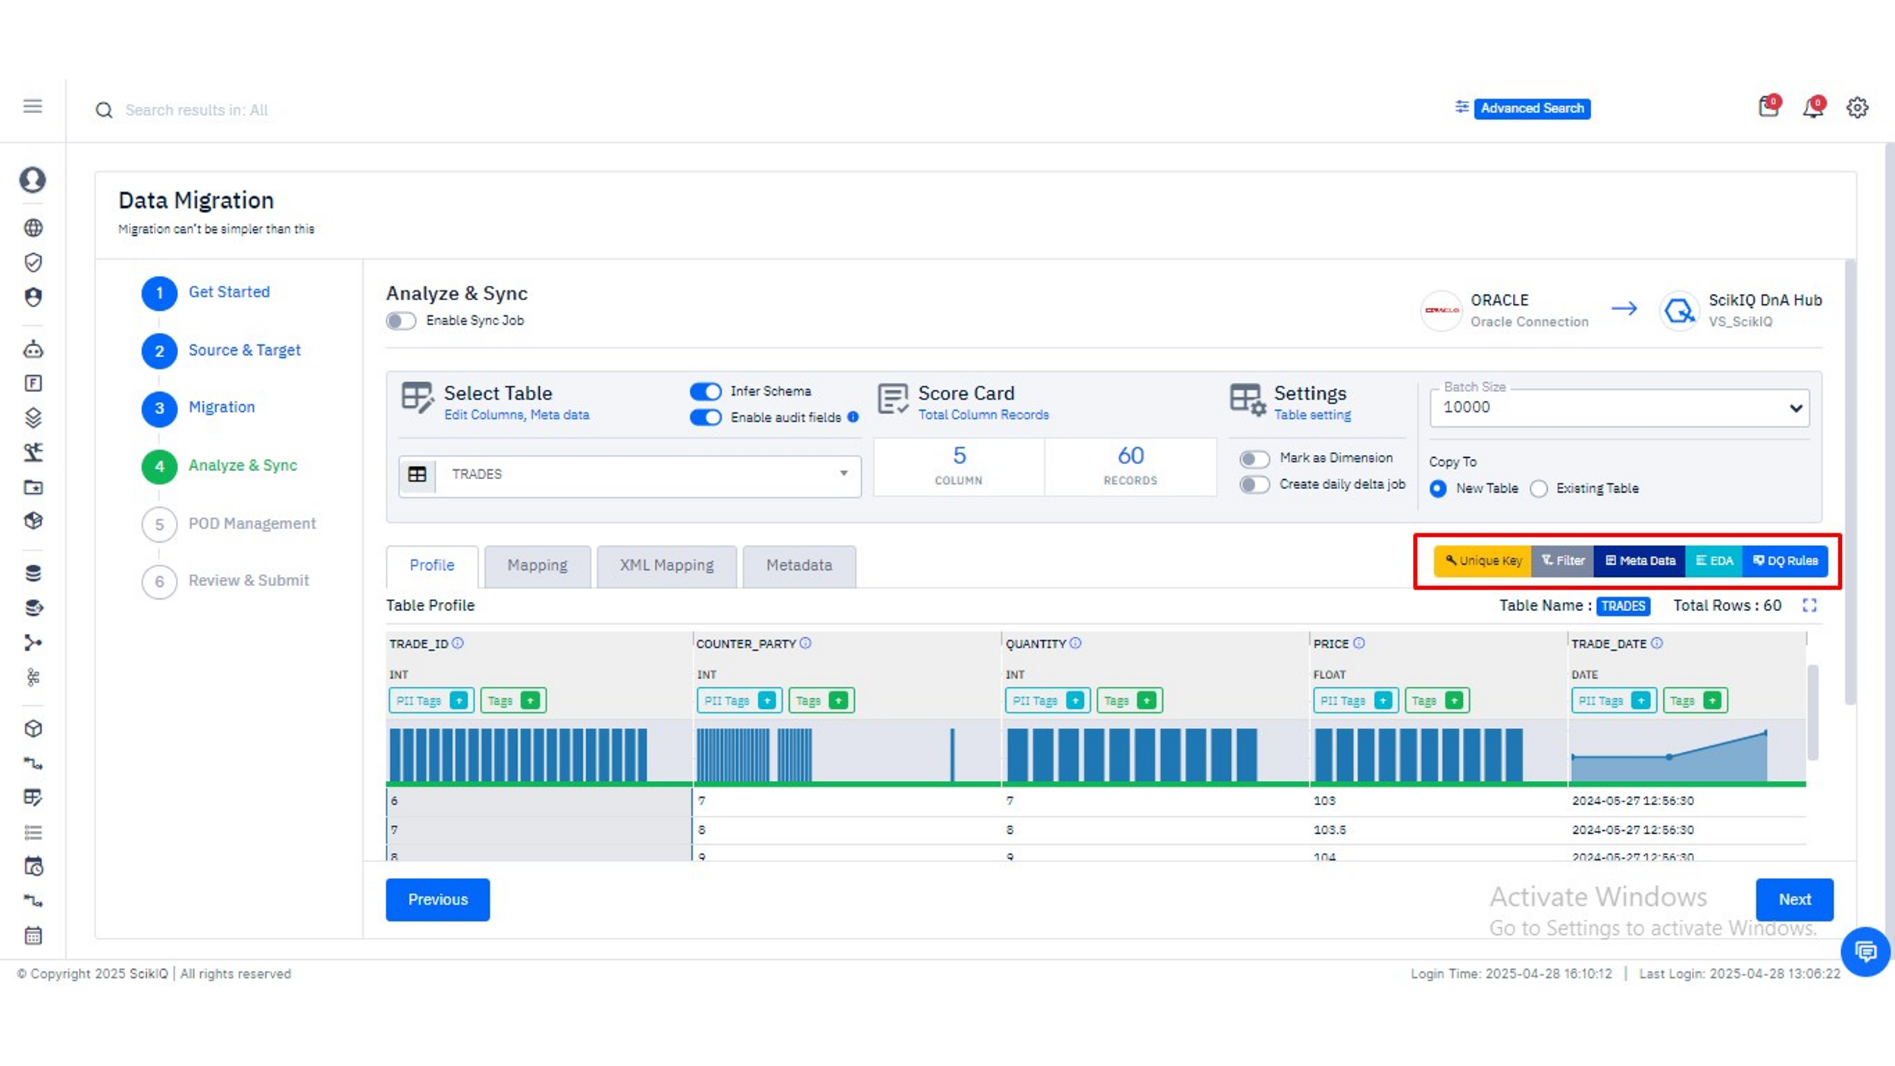
Dimension Flags and Delta Job Creation
This screen helps finalize table-specific settings such as sync type and data destination configuration.
Key Features:
- Mark as Dimension: Identifies the table as a slowly changing dimension, useful in analytical environments.
- Create Daily Delta Job: Configures the sync job to capture and replicate only incremental changes daily, optimizing performance and storage.
- Copy To: Gives users the flexibility to write data into a New Table or an Existing Table on the target system (Vertica in this case).
These controls offer a fine-grained mechanism to support historical tracking (dimension handling) and ensure operational efficiency with delta-based syncing.

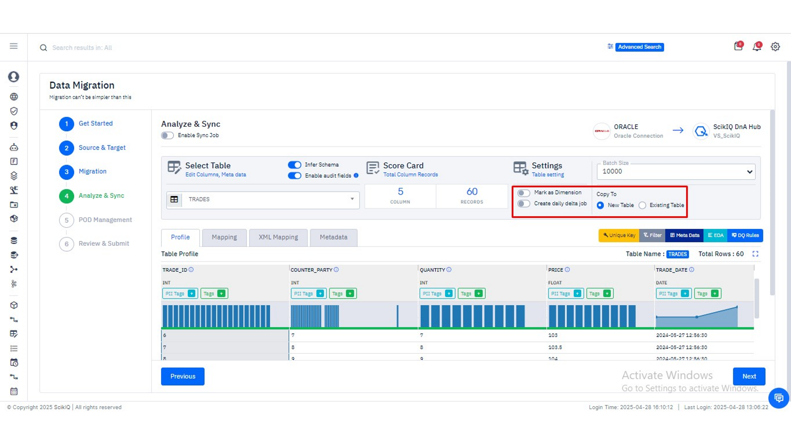
Analyze & Sync - Adding Data Filters
In this phase of the data migration process, SCIKIQ allows users to refine their data transformation pipeline by applying conditional filters on the source dataset before it is written to the target destination. This ensures that only qualified, relevant, and pre-validated data is moved, thereby optimizing storage, enhancing performance, and preserving downstream data quality.
Opening the Add Filter Panel
Upon navigating to the Analyze & Sync section of the Data Migration module, users can initiate the process of applying filters by clicking the Filter button located on the right side of the table profile view. This action triggers the "Add Filter" overlay panel.
In this interface, users can begin defining a custom filter condition by assigning a unique filter name (e.g., test1) and writing an expression using available fields and logical operators. The example illustrated shows the creation of a filter on the field COUNTER_PARTY with a condition COUNTER_PARTY > 23.
The right-hand pane of the dialog offers categorized assistance:
- Operator: Logical symbols such as >, <, =, etc.
- Date & Time: Functions to manipulate or evaluate timestamps
- Column: All available source fields that can be inserted into the filter
This interactive composition environment ensures that filters are both syntactically and semantically accurate.

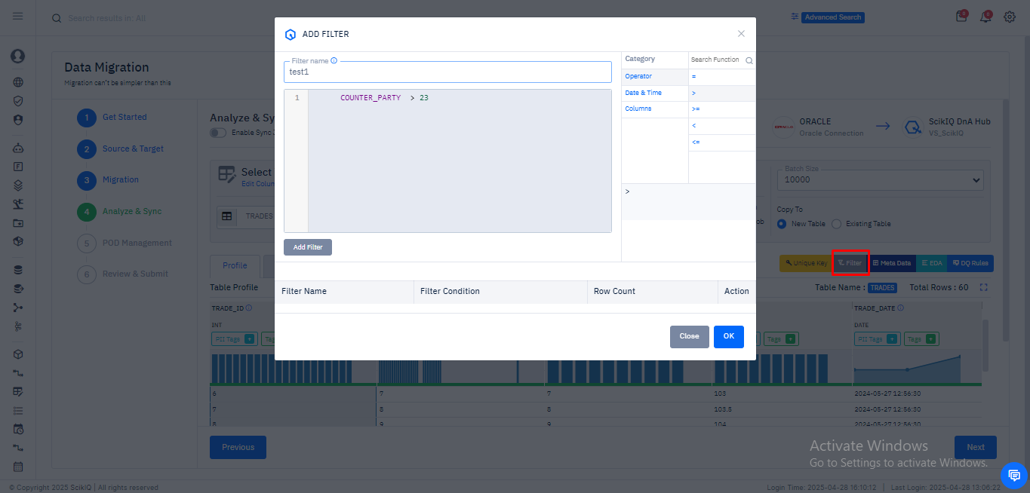

Reviewing and Applying the Filter
After writing the condition, clicking Add Filter validates and records the filter in a structured table beneath the editor. This table includes:
- Filter Name
- Filter Condition
- Row Count (preview of how many records will pass the condition)
In this scenario, the filter COUNTER_PARTY > 23 successfully selects 60 records from the source table.
The user then confirms the inclusion of the filter by clicking OK, which finalizes the filter logic for execution during the sync process. This ensures that subsequent migration operations will apply only to the filtered dataset.
Purpose and Best Practices:
The addition of filters serves multiple strategic purposes:
- Scoping Large Datasets: Limit records to those within a defined business logic
- Compliance and Auditing: Exclude sensitive or invalidated records from being moved
- Efficiency in Delta Jobs: Focus compute resources only on relevant data slices
For optimal design, filters should be defined with clarity, testable logic, and naming conventions that support auditing and reproducibility.
This step in the migration pipeline reflects SCIKIQ's commitment to providing both technical rigor and operational flexibility in enterprise data transformations.

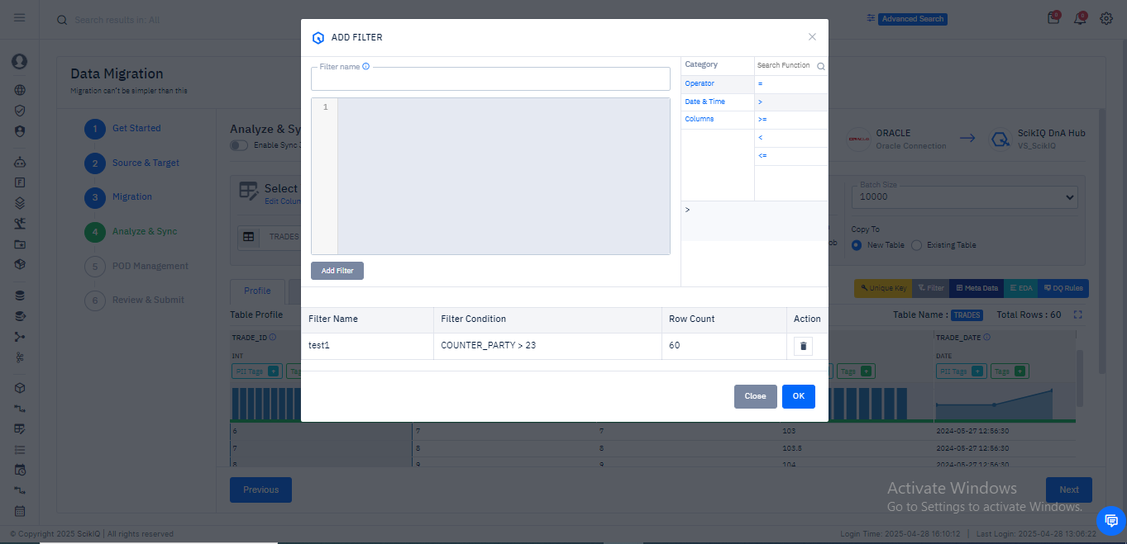
Column Mapping and Table Configuration
Objective:
Define how source table columns map to the target schema and configure table creation behavior before initiating data migration.
Column Mapping Interface
This screen enables users to map source columns from the selected Oracle table to the destination Vertica table.
- Mapping Tab Highlighted:
The active tab "Mapping" allows the user to align source and target columns.
- Column Name vs Target Column:
Each row shows a source column (e.g., TRADE_ID, COUNTER_PARTY, QUANTITY) on the left and a corresponding target field which can be edited or renamed.
- Data Types Auto-Filled:
Based on the source, the system automatically assigns compatible data types such as NUMBER and DATE.
- Add Column Option:
The + Add Column button allows users to manually introduce additional fields into the target schema if needed.
This interface is particularly useful when source and target schemas differ slightly or when enriching the target with derived or additional fields.

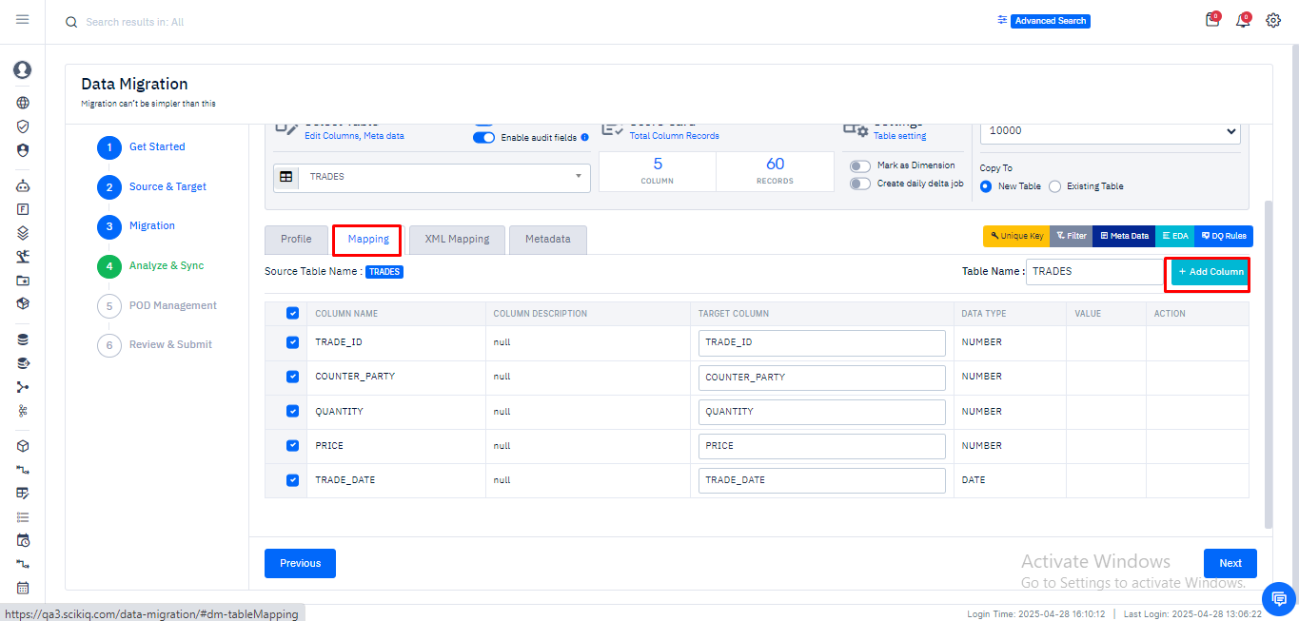

Copy to New Table and Custom Naming
This screen extends the column mapping by introducing destination-specific configurations:
- Copy To – New Table Selected:
A critical setting where users decide whether to write into a new table or an existing one in Vertica. Selecting “New Table” ensures no existing data is overwritten.
- Custom Table Name:
The default destination table name (e.g., TRADES) can be customized (as seen here with TRADES_28thApril) to reflect versioning, testing, or environment-specific use.
- Final Schema Readiness Check:
The mapped fields are verified for consistency, and the destination schema is locked before proceeding to execution.
This configuration ensures auditability and avoids conflicts with existing data structures while giving flexibility in naming and structure replication.

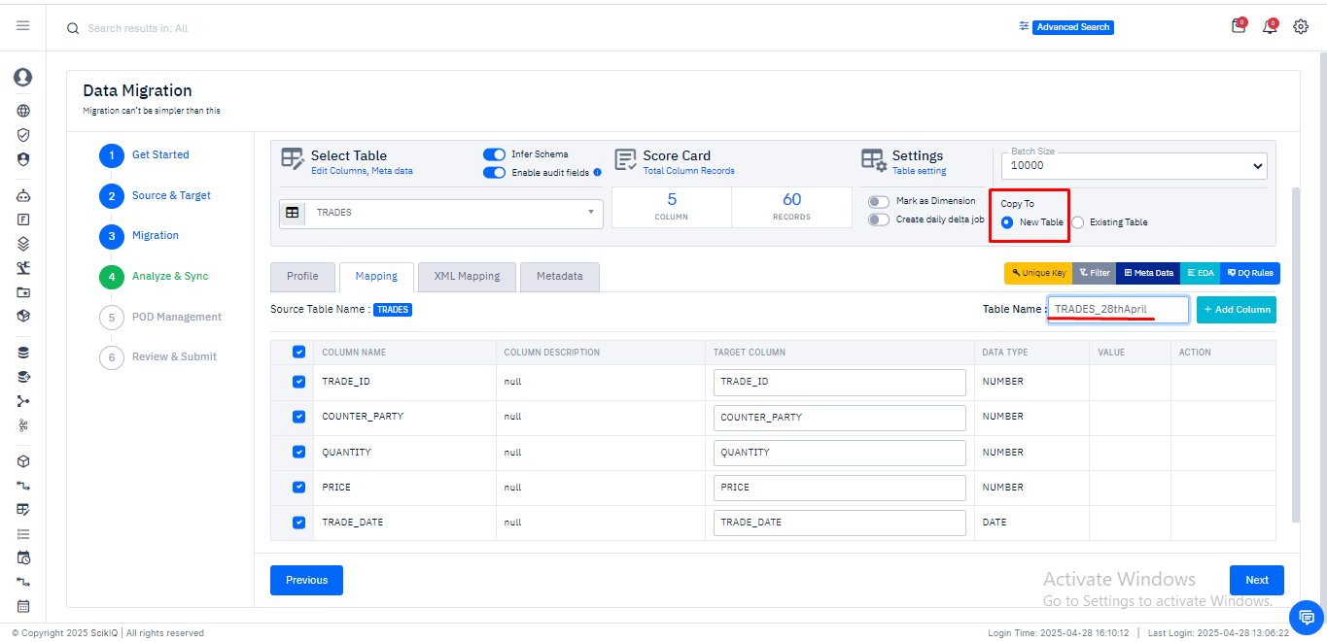

POD Management
Purpose: The POD (Process-Oriented Design) Management step allows users to organize and segment data for migration into logical groupings known as PODs. These groupings help manage and execute table migrations in modular units, increasing clarity and control during large-scale migrations.
Image Reference: The displayed interface showcases the migration configuration screen where two separate PODs are managed: TRADES - test1 and TRADE_OPTIONS.
Functionality Overview:
- Default POD: This is where tables are initially listed by default. In this example, the table TRADES - test1 is shown with metadata indicators for row count, column count, and audit fields.
- Add POD: Users can create additional PODs to logically segment migration tasks. Each POD can be labeled, and tables can be dragged into or removed from these groups.
- Drag-and-Drop Assignment: Tables such as TRADE_OPTIONS have been moved into a newly created POD 2, as seen in the right-hand panel.
- Delete Option: Each POD comes with an option to remove it via a trash icon, allowing full control over organization.
Benefits:
- Enhances clarity for multi-table migrations.
- Enables stepwise or prioritized execution of migration tasks.
- Supports modular testing and execution.

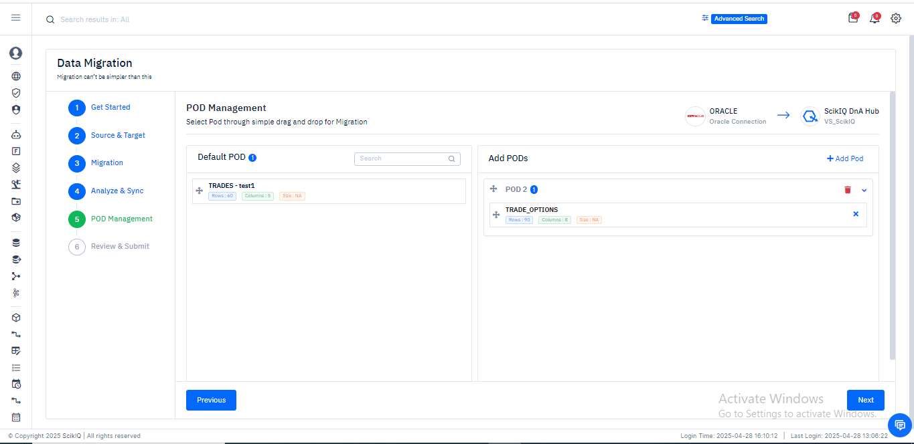
Review & Submit
Purpose: This final step summarizes the migration configuration, allowing users to verify all settings before execution. It ensures accuracy, confirms table mappings, and initiates the migration pipeline.
Image Reference: The screenshot presents the review screen titled "Review & Submit," with clearly defined task details and selected table mappings.
Functionality Overview:
- Task Name and Description: Users can assign a custom task name (e.g., Trade Table Migration) and description for traceability.
- Source and Destination Overview: A summary box highlights the connection mapping from source (e.g., Oracle Connection) to destination (Vs_Scikiq).
- Table Mapping Summary:
  - Source Tables: TRADE_OPTIONS, TRADES
  - Corresponding Target Tables: TRADE_OPTIONS, TRADES_28thApril
  - Flags indicating whether these are new or existing tables.
  - Truncate flags confirm whether the target tables will be emptied before migration (set to "No" here).
- Final Action: Clicking the Finish button triggers the full migration process as per the reviewed configuration.
Best Practices:
- Double-check all target table names to avoid overwrite or data mismatch.
- Ensure POD assignments reflect business logic or batch strategy.
- Validate audit fields and delta job settings if applicable.
The POD Management and Review & Submit steps conclude the setup of a well-structured data migration process. By enforcing verification and logical grouping, SCIKIQ ensures enterprise-grade reliability and traceability for every migration task.

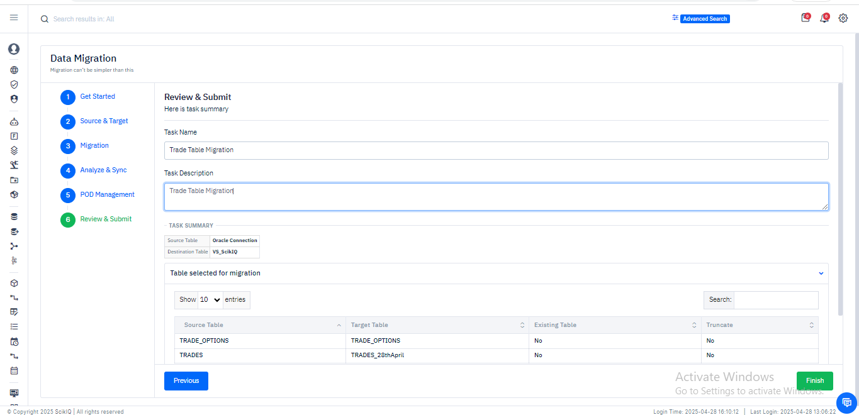

Confirmation of Data Migration Job Creation
After configuring all required parameters and submitting the migration job from the Review & Submit section, the system displays a confirmation dialog indicating the successful creation of the data migration job.
- Message Displayed: "Data migration job is created successfully!"
- Status: The job is tagged with a system-generated status – CREATED, signifying that the request has been successfully registered in SCIKIQ’s orchestration system.
- Request Number: A unique request identifier (e.g., DTAMCLINT0043000064) is generated and assigned for downstream tracking and audit purposes.
- Submitted By: The identity of the initiating user (e.g., "Vimlesh Singh") is logged and displayed.
- User Action: Clicking OK will close this confirmation and redirect the user to the migration job listing interface for further monitoring or execution.
This acts as a critical checkpoint ensuring task integrity, auditability, and traceability before executing potentially large-scale data transformations.

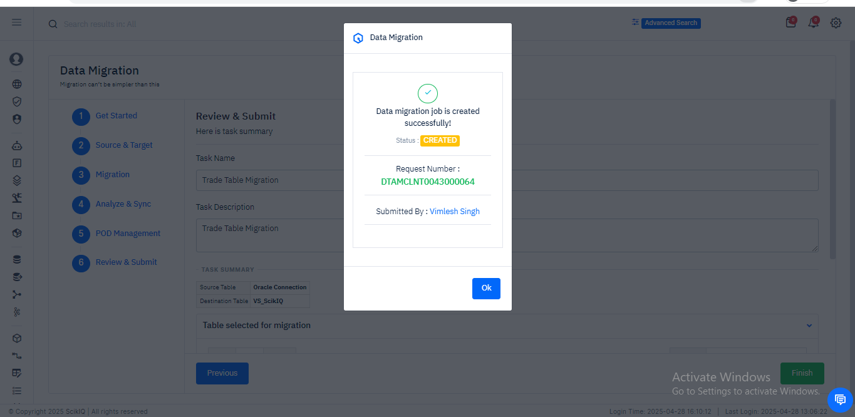
Navigating to Migration Request Dashboard
Once the job is created, users are redirected to the Data Migration Request dashboard which provides a comprehensive view of all submitted migration jobs.
- Job Listing Panel: Lists multiple migration jobs including historical records. Each job is represented by a card showing:
  - Source and target systems (e.g., Oracle → SCIKIQ DNA Hub).
  - Status of the job (CREATED, FINISHED, ERROR, etc.).
  - Action buttons (RUN, RE-RUN, CREATE PHYSICAL MODEL) for control and rerun.
- Quick Filters: Users can filter by job status, data source, or page size for effective tracking.
- Action Highlight: The topmost job (DTAMCLINT0043000064) is in CREATED state and ready to be executed using the RUN button.
This dashboard offers real-time visibility into all data migration workflows, supporting governance, operational tracking, and error resolution at scale.

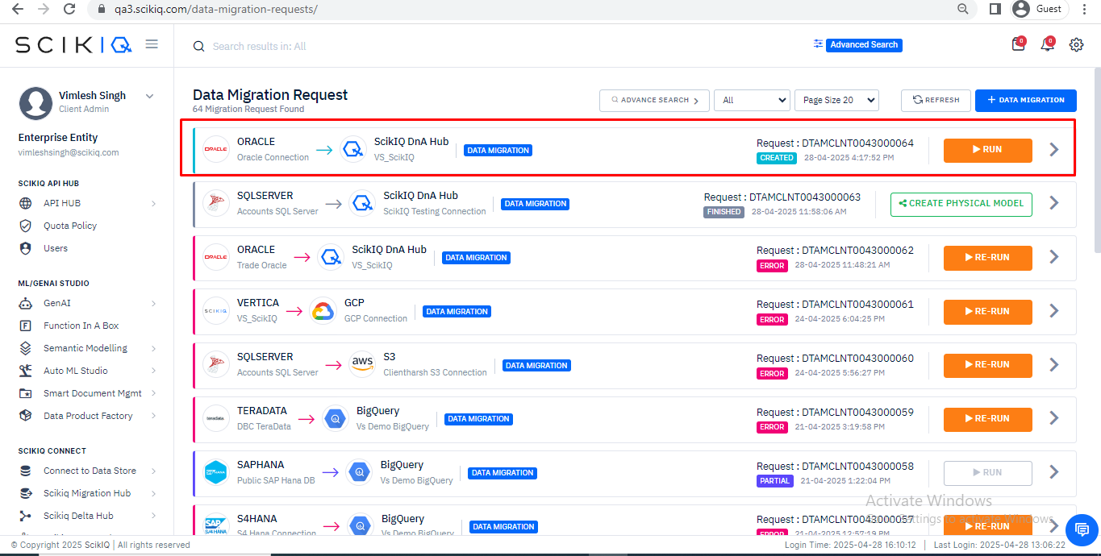

Viewing Migration Request Summary
Clicking on a job card expands the Request Detail View that presents a job-specific breakdown:
- Meta Information: Includes:
  - Task name and description.
  - Request ID.
  - Submission time and initiator’s identity.
- Current Status: Still listed as CREATED, indicating readiness for execution.
- Pod Assignment Panels:
  - Tables like TRADES_28thApril and TRADE_OPTIONS are organized into Pods (POD1, POD2).
  - Status indicators for tasks like Pod Assignment, Source Stats Capture, Data Copy, and Discovery.
- Filter Used: Custom filters (e.g., test1) are shown against each table when applied during preprocessing.
- Execution Timeline: Start times are recorded and displayed; end time updates upon completion.
This screen serves as the command center for migration execution monitoring, revealing the lifecycle stage of each table and transformation involved in the job.

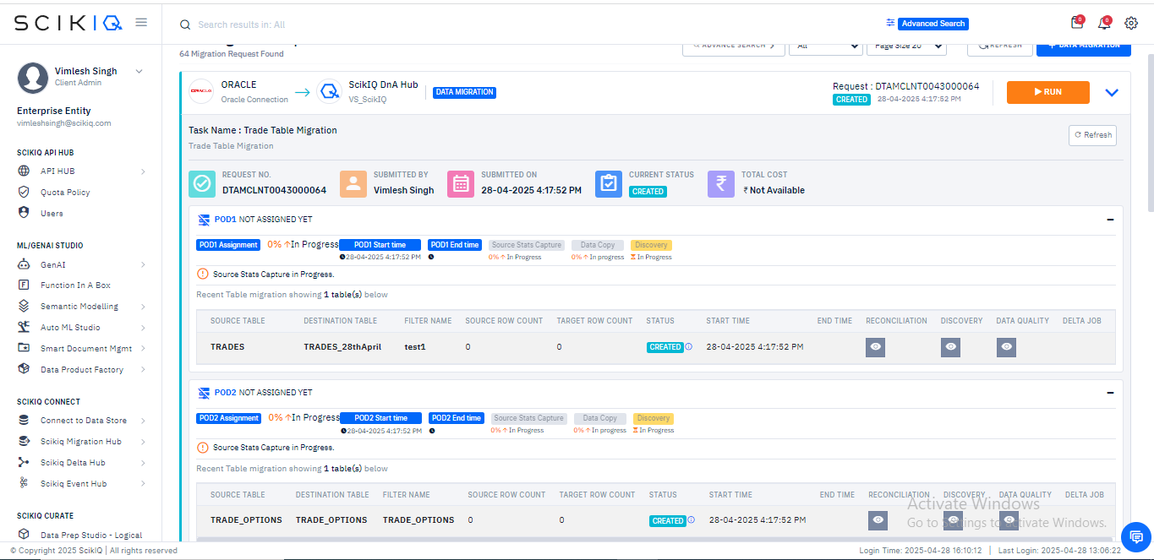
Confirmation of Migration Job Execution Start
Upon clicking the RUN button, a toast notification appears at the bottom right of the screen:
- Message: “Data Migration Started”
- Visual Cue: Green success indicator confirms that the system has transitioned from configuration state to execution.
This final interface feedback validates the system’s responsiveness and helps the user transition focus from job setup to performance tracking and post-migration analysis.
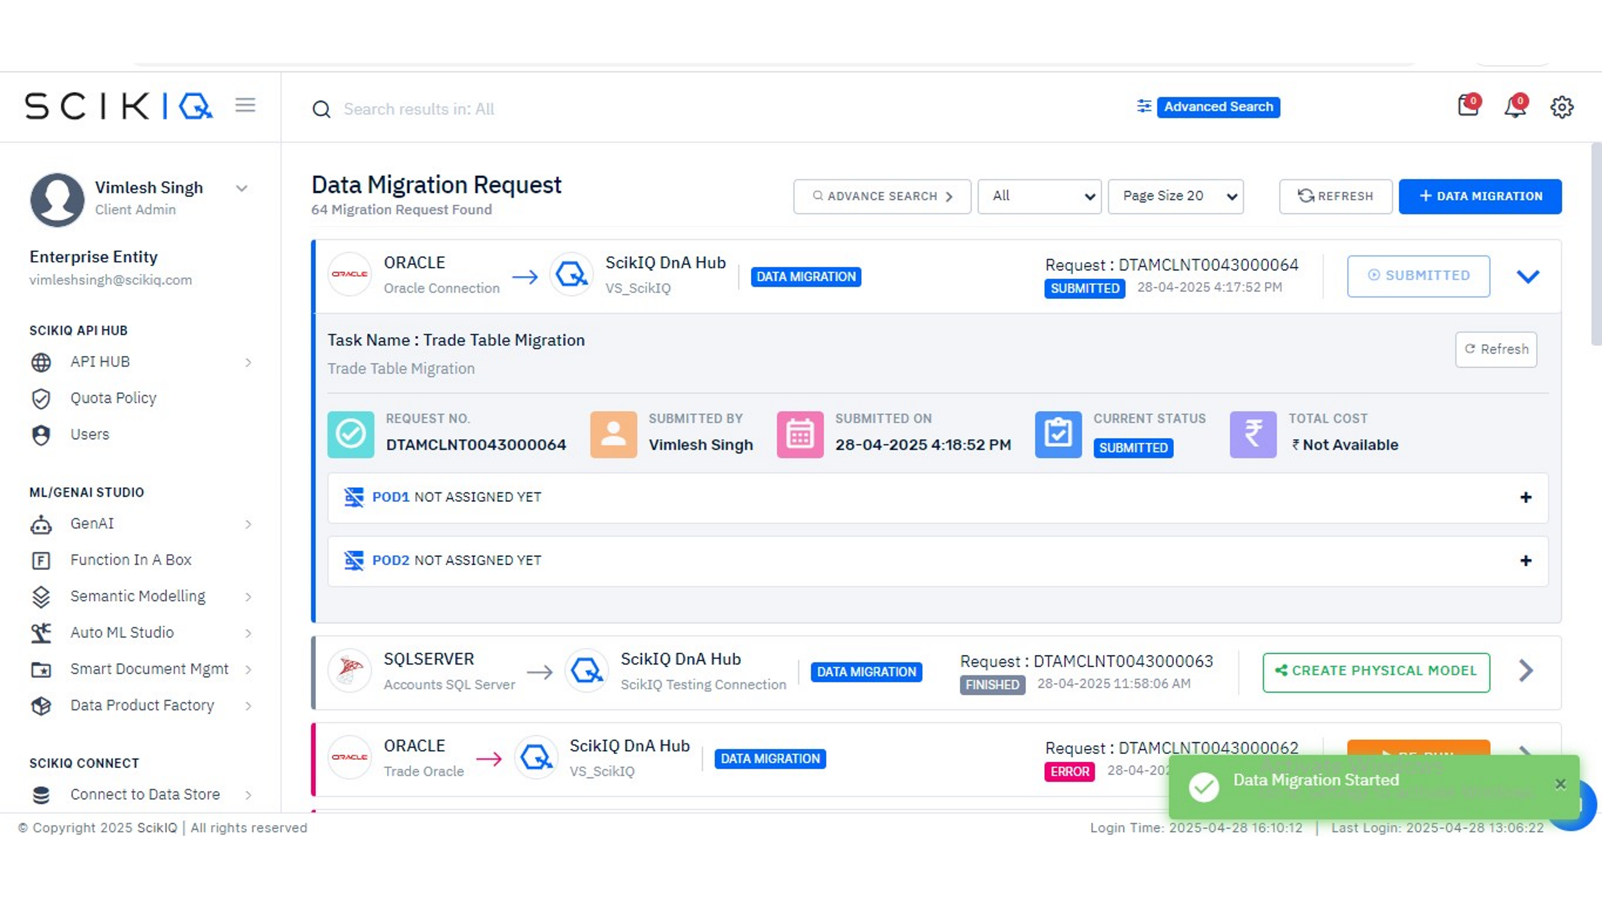

Monitor Real-Time Job Execution – Status: In Progress
Once the user triggers the migration process, the job status transitions from CREATED to IN PROGRESS, indicating the pipeline is actively processing the data from the source (Oracle) to the target (SCIKIQ DnA Hub).
Key observations:
- Progress Bars show the sequential execution of subtasks:
  - POD Assignment
  - Source Stats Capture
  - Data Copy
  - Discovery
- Highlight: A green progress bar shows the completed step Source Stats Capture, while Data Copy and Discovery are still running.
- Filter Application: The custom filter test1 remains associated with the TRADES table migration.
- Time Tracking: Each step logs start and end timestamps, aiding in performance audits and operational benchmarking.
This stage provides transparency in execution and is critical for identifying runtime bottlenecks or latency issues.

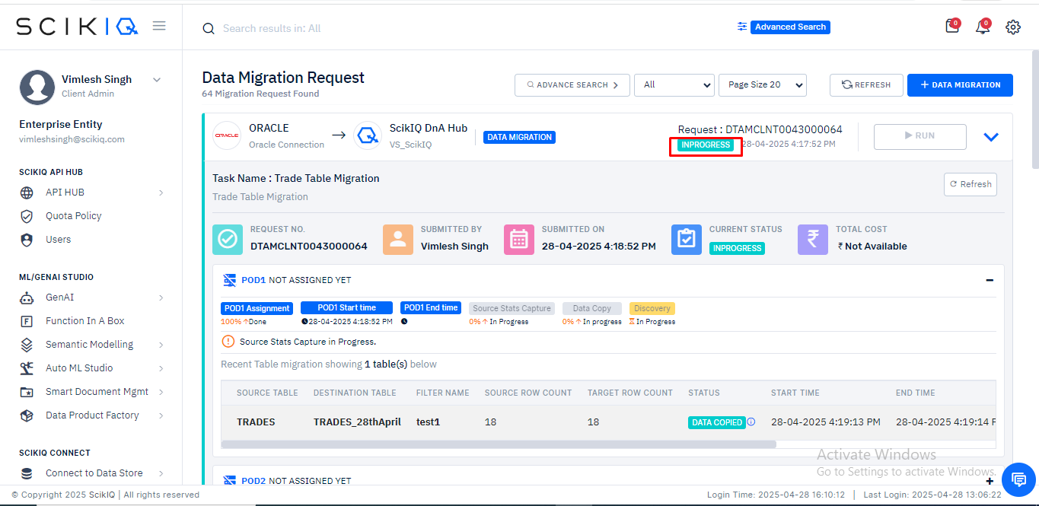

Job Status – Data Copied
Once the data extraction, transformation (if applied), and load (ETL) are complete, the job status is updated to DATA COPIED.
Highlights:
- Orange Label (DATA COPIED) is shown both at the job level and table level.
- Pod Details: Information for POD2 has also appeared, indicating parallel execution for different tables.
- Execution Trail: Each subtask's execution % and status (e.g., 100% Done, 0% Done, In Progress) are visible.
- Control Panel: Discovery and Data Quality checks remain optional at this point.
This serves as a checkpoint before entering validation stages such as reconciliation, metadata verification, and downstream audit readiness.

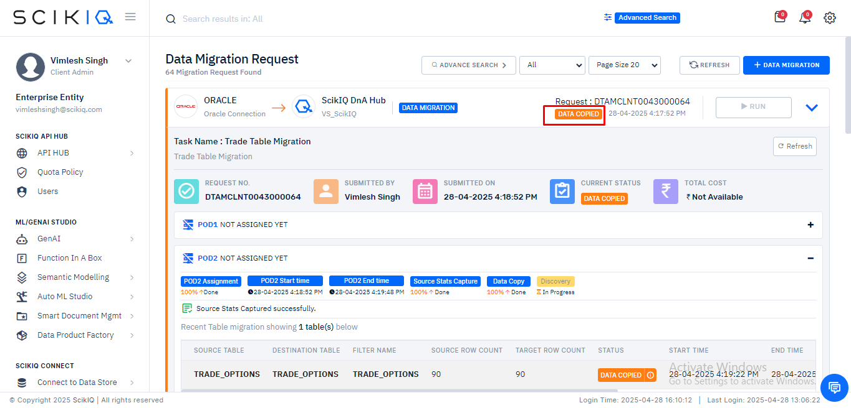
Row-Level Reconciliation – Green Signal
The job details pane now shows the reconciliation indicator as green, signifying that row-level reconciliation has passed successfully.
Breakdown:
- Source Table: TRADES
- Destination Table: TRADES_28thApril
- Source/Target Row Count: Both equal to 18
- Start/End Time: Clearly recorded with millisecond precision
- Status: DATA COPIED
- Reconciliation Status: Green tick confirms that row count matches and no data integrity violation has occurred.
This screen is pivotal for regulatory compliance in industries like finance and healthcare where reconciliation logs are mandatory for audits.

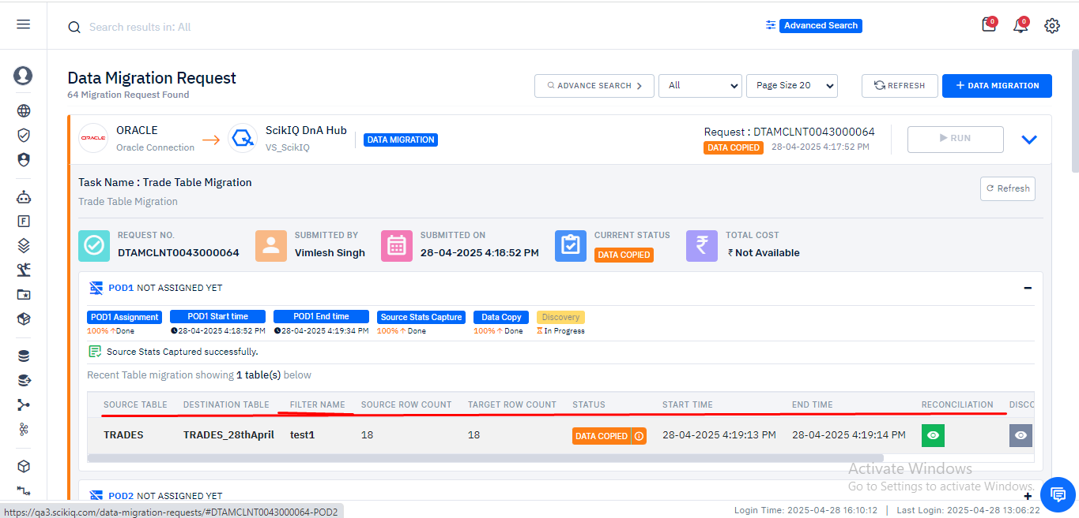

Column-Level Profile Validation
Clicking on the reconciliation tile brings up a column-level table profile, offering detailed insights into each column’s transformation and integrity post-migration.
Attributes Tracked:
- Source vs Destination Column Name and Type
- Source/Target Count (Total, Null, Unique)
- Data Type Mapping (e.g., NUMBER → numeric(37,15), DATE → timestamp)
Additionally:
- A CSV Export button allows users to download the reconciliation results for offline reporting or audit archival.
This in-depth validation ensures semantic consistency and confirms that no corruption or loss occurred during migration essential for mission-critical datasets.

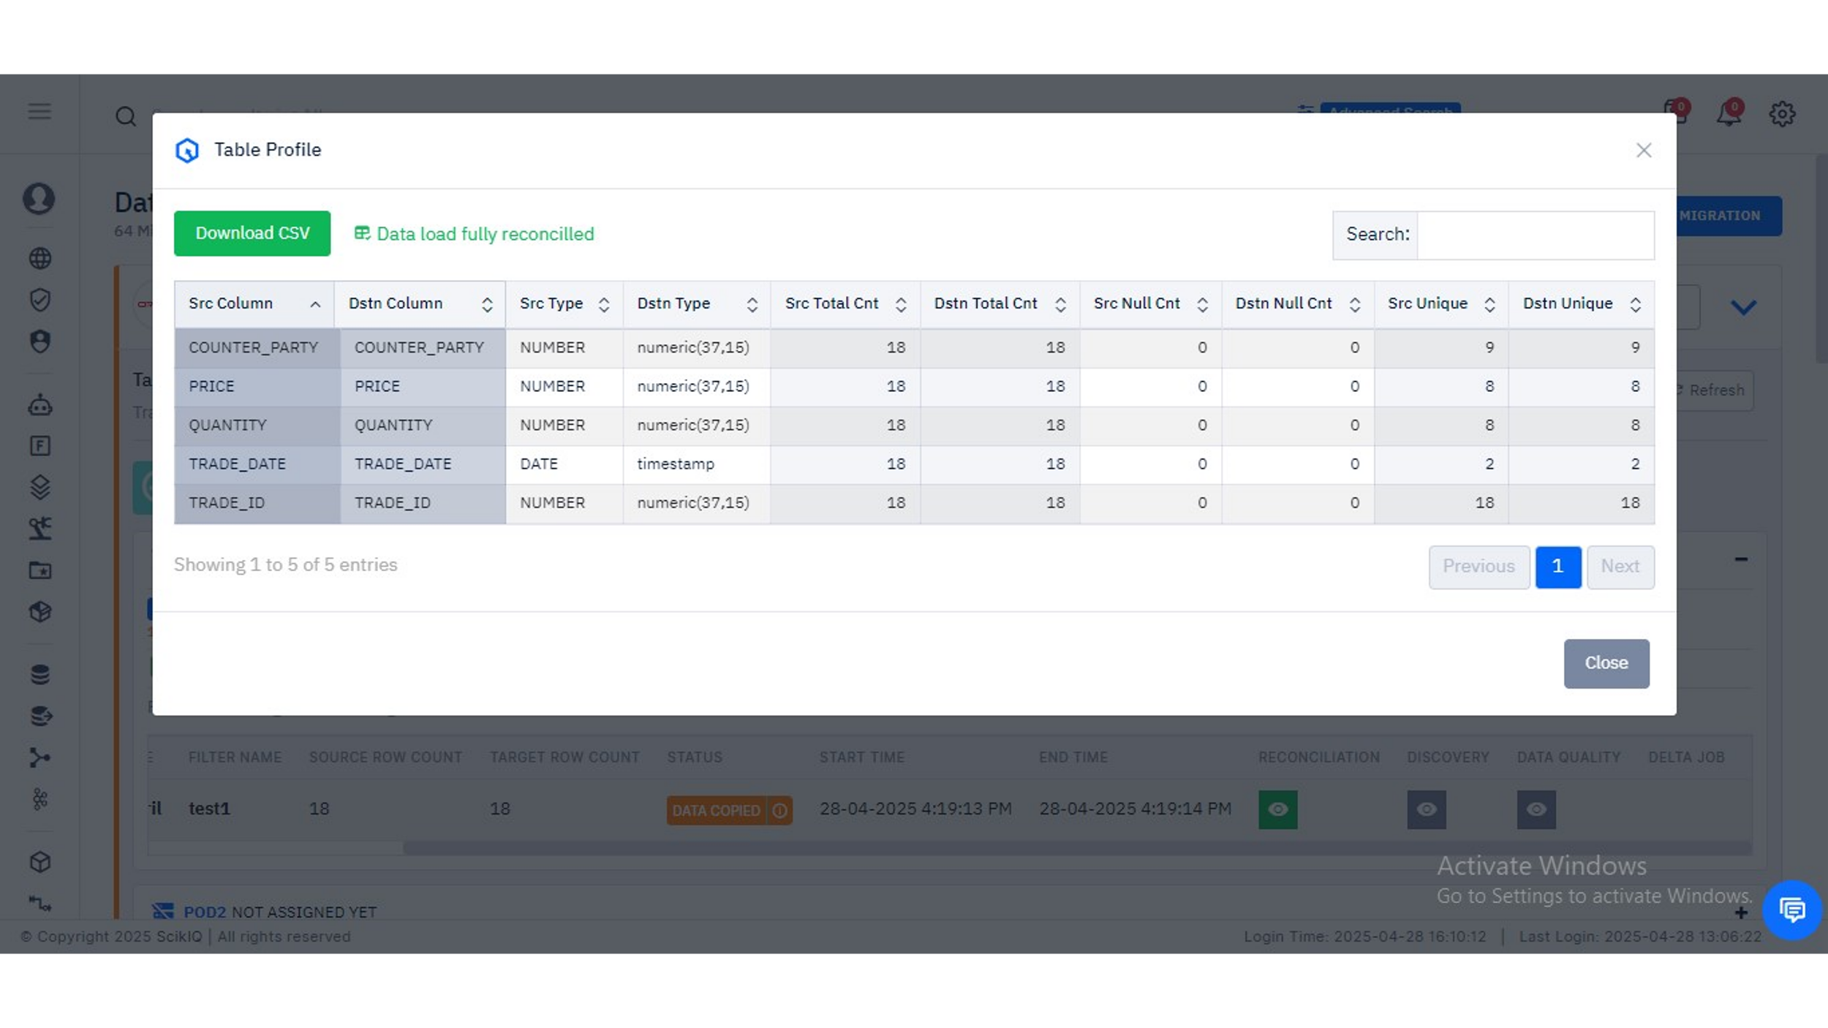
Reconciliation Summary Panel
The bottom section of the job view provides a dashboard-style summary across multiple quality dimensions:
- Reconciliation: Green means success
- Discovery: Indicates if metadata discovery has been completed
- Data Quality: Assessment of nulls, data types, uniqueness, etc.
- Delta Job: If enabled, delta handling or change data capture is shown
These toggles empower the user to:
- Trigger advanced metadata analysis
- Flag schema anomalies or drift
- Validate business rules through pre-defined quality checks
This final visual check establishes trustworthiness and completeness before handing the data over to BI tools, analytics layers, or business teams.

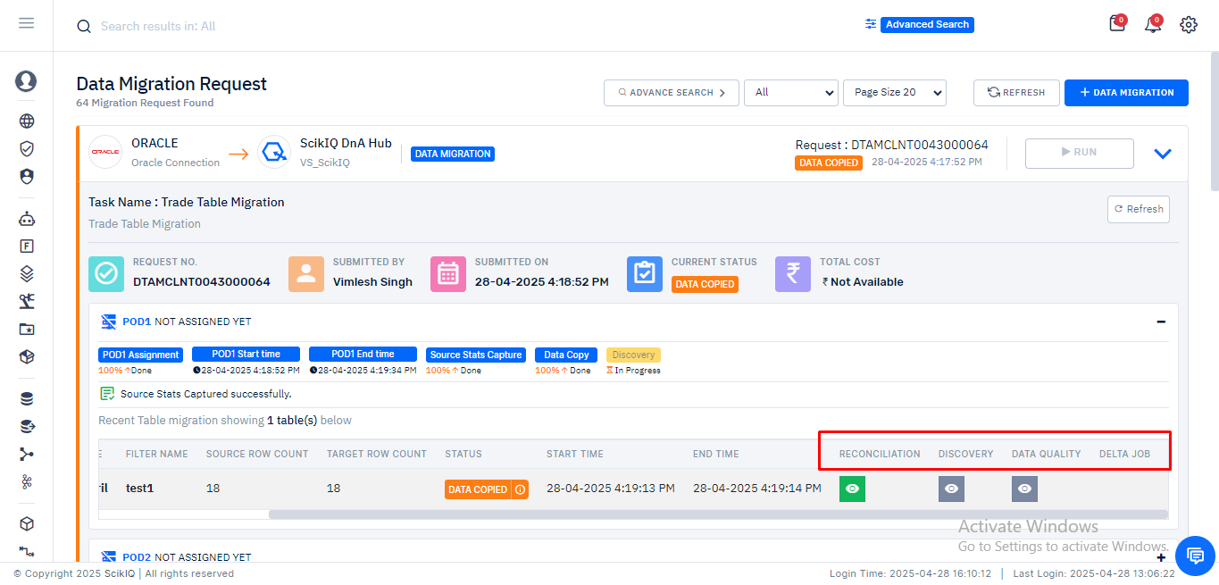

Final Migration Status, Physical Model Creation, and Job Tracking
Final Migration Summary Panel
This image provides a comprehensive summary of a data migration task post-execution. It showcases the metadata associated with the migration job, including:
- Request Number: DTAMCLNT0043000064
- Submitted By: Vimlesh Singh
- Submission Date: 28-04-2025 04:17:52 PM
- Current Status: Data Copied (green label)
- Total Cost: Not Available (indicative of either cost not yet calculated or cost tracking disabled)
Below the metadata block, the panel captures the pod assignment and task lifecycle events:
- POD1 Assignment and Timeline: 100% completed; all components like Source Stats Capture, Data Copy, and Discovery are tracked with visual progress indicators.
- Execution Logs: Confirmed start and end times of the task steps (Source Capture, Copy, and Discovery)
- Row Statistics: Source Table TRADES was migrated into TRADES_28thApril with 18 source rows, 18 target rows, and status marked as Data Copied.
This panel is critical for auditability and governance teams to review the data pipeline completion status and monitor for data integrity.

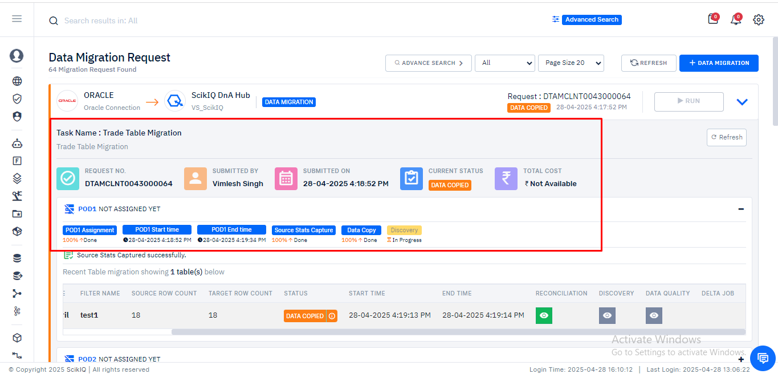

Image 2: Migration Completion and Transition to Physical Model Creation
Upon successful data migration and reconciliation, the job status is marked as FINISHED, as indicated in the top header.
A key feature becomes available here: "Create Physical Model". This option is highlighted in green and serves as the logical next step post-migration. It allows users to:
- Visualize the structure of newly ingested tables
- Build relational mappings between tables (primary/foreign key relationships)
- Prepare the data for downstream consumption in analytics and reporting workflows
This interface links data migration with semantic and data modeling tasks, ensuring continuity in the data lifecycle.

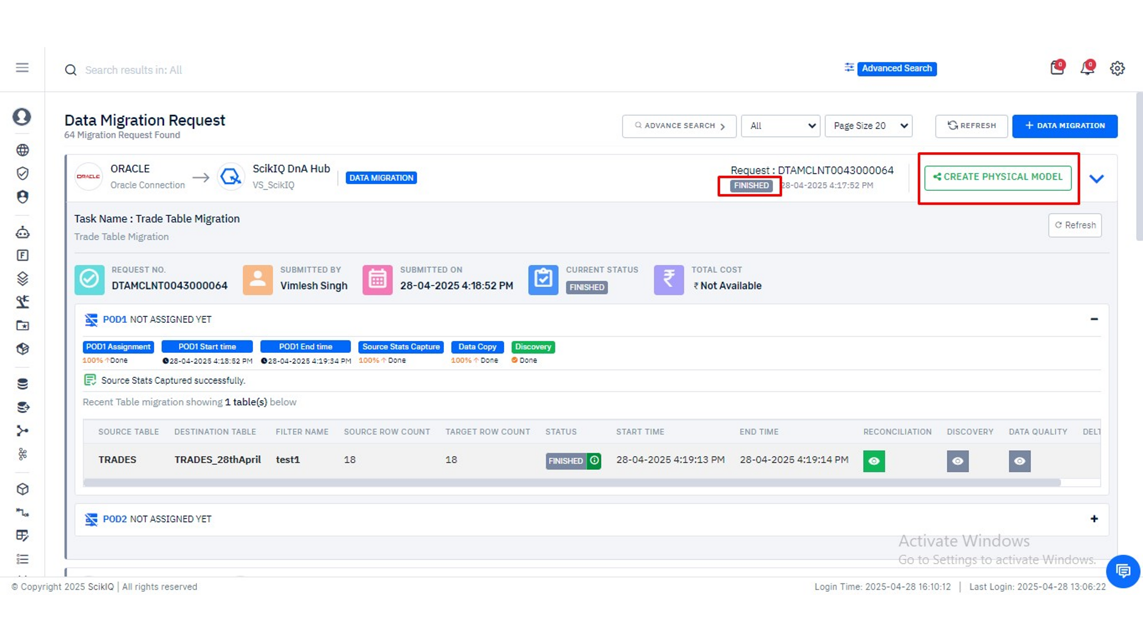
Physical Model Canvas Interface
This image showcases the Physical Model Designer Studio, where the user has successfully pulled the migrated tables (TRADES_28thApril and TRADE_OPTIONS) into the design canvas.
Key highlights:
- Tables Available on Left Panel: A full list of entities accessible within the current data source (VS_SciKiQ)
- Canvas Area: Allows drag-and-drop functionality for selected tables
- System Columns Auto-Appended: Columns such as ska_created_at, ska_updated_at, etc., are automatically injected for operational metadata tracking
- No active joins defined yet: This is an opportunity for users to establish relationships between entities for lineage and business semantics
This step is fundamental for constructing enterprise-ready datasets suitable for semantic querying, BI visualization, or publishing to other systems

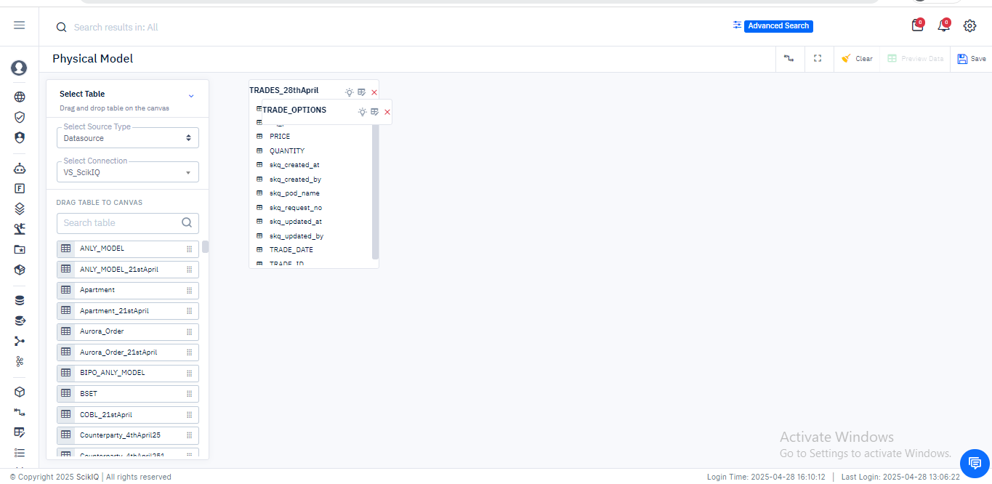

Advanced Search and Filtering of Migration Jobs
The final image illustrates the Data Migration Dashboard’s Advanced Search Panel, a feature built to help users track and manage large volumes of migration tasks.
Functional elements:
- Filter by Migration Status: Dropdown options include All, Created, In Progress, Submitted, Data Copied, Partial, Finished, and Error
- Pagination Controls: Page size selectors (e.g., 20 results per page)
- Search Filters: Source Type, Target Type, Connection Names, and Table Identifiers can all be used to narrow down results
This tool is essential for administrators and project managers who oversee numerous migrations across different systems. It ensures traceability, performance auditing, and quick access to problematic or completed jobs.



